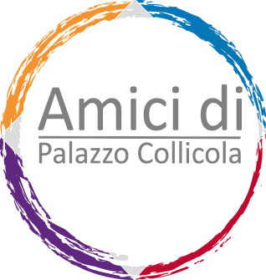

DESIDERO SOSTENERE L’ASSOCIAZIONE

**AMICI DI PALAZZO COLLICOLA**

**Individual Membership Fees:**

* **Junior Ordinary Member** (under 30) invitation to previews for 2 people

€ 25

* + **Ordinary Member** invitation to previews for 2 people

€ 60

* **Plus Member** **+** copy of the exhibition catalog

€ 100

* **Special Member** **+** ad hoc guided tour with director and artists – bookshop discount

€ 250

* **Special Plus Member +** aperitifs with the artists on the occasion of the inauguration of exhibitions – visit to artists’ and collectors’ studios

€ 500

**Company Fees:**

* **Guest** € 1000 **+** special events that can be organized during closing times for corporate guests, special guests
* **Sponsors** € 2000 **+** possibility to appear as official sponsor of the initiatives of Palazzo Collicola in catalogs, press, etc. Copies of limited edition works, signed by the artists.

**P.S.: the +** means comprising everything included in the previous offer

Name and surname ____________________________________________

Address _____________________________________________________

Phone nr. ____________________________________________________

E-mail _____________________________________________________

Banco Desio

IBAN CODE: IT 79 F0344021800000000 225400

BIC BDBIT22

MOTIVE OF PAYMENT: DONATIONS

Spoleto, ____/____/____ Sign ___________________________________